PROJECT

NAME:S.LAKSHMIBHARGAVI

BRANCH:EEE

YEAR:III-EEE-B

COLLAGE:AITS

DC MOTOR SPEED CONTROL(PID SIMULATION)

AIM: Dc motor speed control (pidsimulation)

DISCRIPTION: The PID controller adjusts the voltage applied to the motor based on the difference between the desired speed (setpoint) and the actual measured speed, aiming to minimize this error.

PROGRAM:

import matplotlib.pyplot as plt

import numpy as np

setpoint = 100  # Desired motor speed (RPM)

Kp = 0.1        # Proportional gain

Ki = 0.01       # Integral gain

Kd = 0.05       # Derivative gain

dt = 0.1        # Time step for simulation (seconds)

sim_time = 150   # Total simulation time (seconds)

integral = 0

previous_error = 0

motor_speed = 0  # Initial motor speed (RPM)

# Store data for plotting

time_data = []

speed_data = []

integral = 0

previous_error = 0

motor_speed = 0  # Initial motor speed (RPM)

# Store data for plotting

time_data = []

speed_data = []

for t in np.arange(0, sim_time, dt):

    # Calculate error between setpoint and current motor speed

    error = setpoint - motor_speed

# Proportional term

    P_out = Kp * error

    # Integral term (accumulation of past errors)

    integral += error * dt

    I_out = Ki * integral

    # Derivative term (rate of change of error)

    derivative = (error - previous_error) / dt

    D_out = Kd * derivative

# Calculate the total control output

    control_output = P_out + I_out + D_out

    # Simulate the motor speed response (simplified linear response)

    imotor_speed += control_output * dt

# Update the previous error for the next iteration

    previous_error = error

    # Save data for plotting

    time_data.append(t)

    speed_data.append(motor_speed)

# Plot the motor speed over time

plt.plot(time_data, speed_data)

plt.title('DC Motor Speed with PID Control')

plt.xlabel('Time (s)')

plt.ylabel('Speed (RPM)')

plt.grid(True)

plt.show()

OUTPUT:

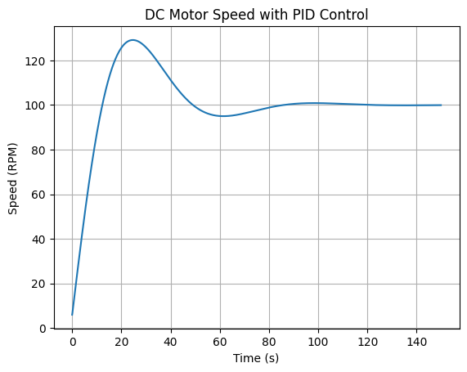

CONCLUSION:

PID controllers are highly effective in regulating DC motor speed due to their ability to minimize error through proportional, integral, and derivative actions.